PRANAV RAIKAR

D15A 47

AIM: To design Flutter UI by including common widgets.

Theory:

In summary, Flutter widgets are fundamental components in constructing the user interface of a Flutter application. They can be broadly categorized into two types: `StatelessWidget` representing immutable parts of the UI and `StatefulWidget` representing mutable components that can change over time.

Some key Flutter widgets include:

1. Scaffold: The basic structure for a Flutter app, providing layout elements such as AppBar, BottomNavigationBar, and a body for main content.

2. Container: A versatile box model used for layout, padding, margin, decoration, and constraints, capable of containing other widgets.

3. Row & Column: Widgets for arranging child widgets horizontally (Row) or vertically (Column), essential for creating flexible and responsive layouts.

4. Text: Used for displaying text on the screen with support for various styling options like font size, color, and alignment.

5. TextField: Captures user input, such as text, numbers, or passwords, with the `onChanged` property for dynamic updates based on user input.

6. Buttons: Various button widgets like `ElevatedButton` or `TextButton` trigger actions when pressed, providing a means for user interaction.

7. Forms: The `Form` widget manages a group of `TextFormField` widgets, facilitating input validation and submission.

8. Icons: The `Icon` widget displays icons from libraries, enhancing visual elements and conveying meaning through symbols.

Key Design Principles highlighted include:

- Consistency: Common widget usage fosters a consistent design language throughout the app.

- Responsive Layouts: Widgets like `Row` and `Column` aid in creating responsive and flexible layouts, adapting to different screen sizes.

- User Input Handling: `TextField` and `Form` widgets facilitate proper handling, ensuring data integrity and validation.

- Interactive Elements: Buttons and icons contribute to interactivity and user engagement within the app.

- Visual Styling: The `Container` widget and styling properties of other widgets allow for visual customization and theming.

Common widgets is used for different type of fonts:

// ignore_for_file: prefer_const_constructors, non_constant_identifier_names

import 'package:flutter/material.dart';

class AppWidget {

static TextStyle boldTextFieldStyle() {

return TextStyle(

color: Color.fromARGB(255, 50, 32, 32),

fontSize: 20.0,

fontWeight: FontWeight.bold,

fontFamily: 'Poppins');

}

static TextStyle HeadlineTextFieldStyle() {

return TextStyle(

color: Color.fromARGB(255, 50, 32, 32),

fontSize: 24.0,

fontWeight: FontWeight.bold,

fontFamily: 'Poppins');

}

static TextStyle LightTextFieldStyle() {

return TextStyle(

color: Color.fromARGB(255, 50, 32, 32),

fontSize: 15.0,

fontWeight: FontWeight.w500,

fontFamily: 'Poppins');

}

static TextStyle semiBoldTextFieldStyle() {

return TextStyle(

color: Color.fromARGB(255, 50, 32, 32),

fontSize: 15.0,

fontWeight: FontWeight.bold,

fontFamily: 'Poppins');

}

}

In above picture AppWidget is the widget which is common at many places in code

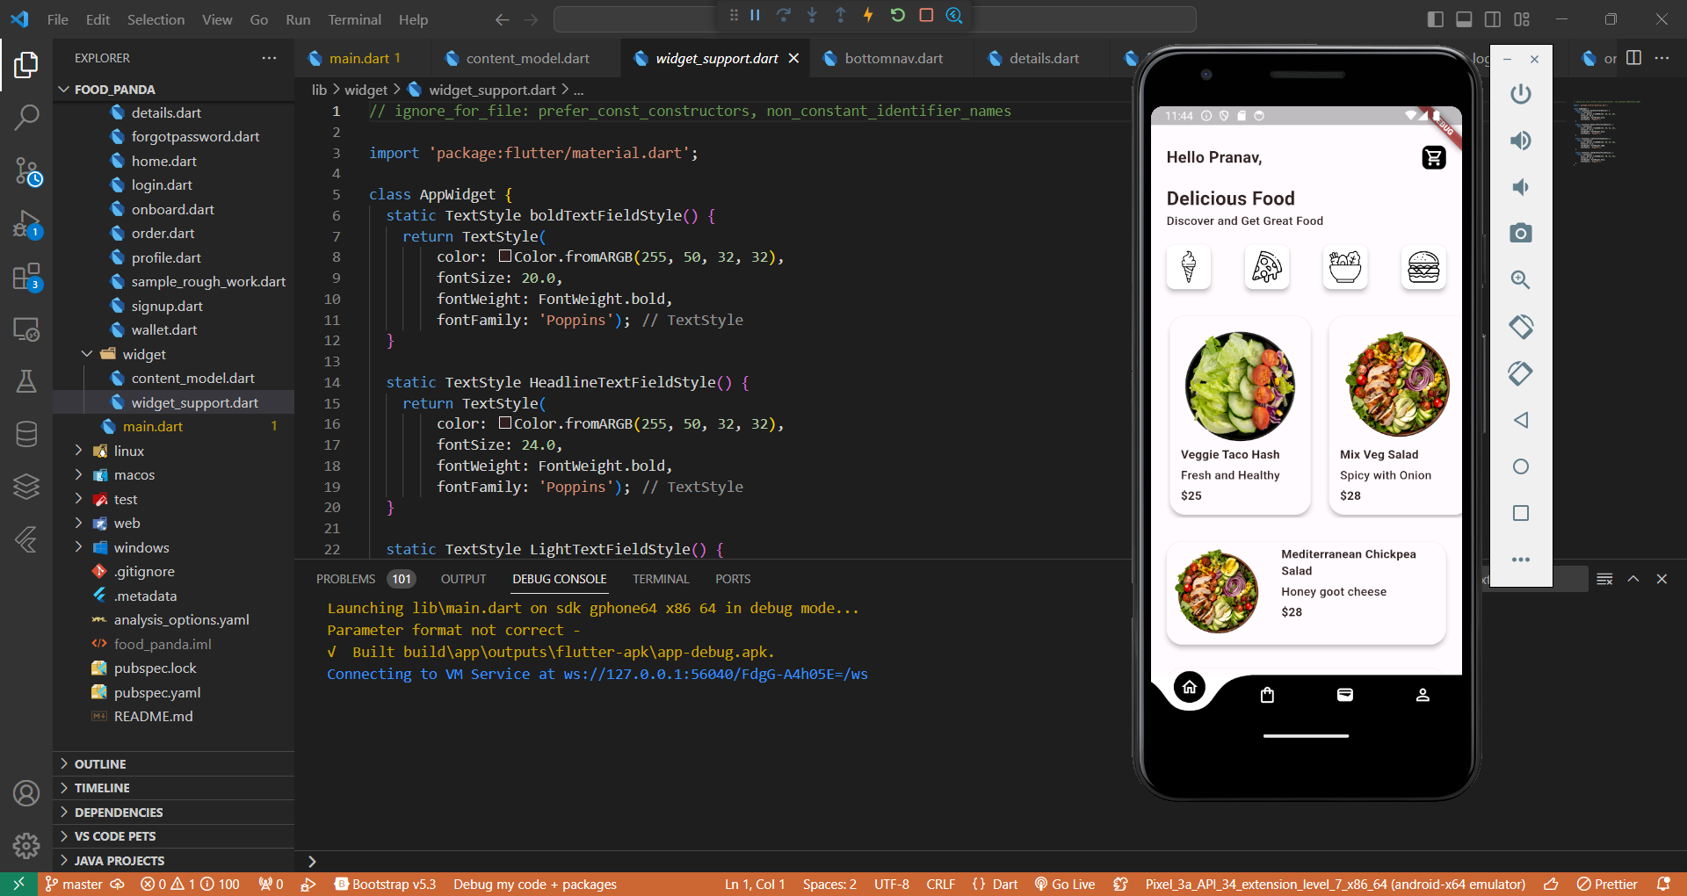

Conclusion :Thus I learnt to create and use common widgets